Documentaie
Tema: model urdf animat de un node
Nume: Peteu Mircea

Cap 1, Modelul

Comenzi folosite:
$ cd ../.. (navigare in terminal, in cazul asta desktop)
$ touch –filename.extension- (creat un file cu numele “robot_T2.urdf”)
$ touch –x –filename.extension- (declaram ca este executabila file-ul creat)
$ code –filename.extension- (open –filename.extension- in vs code to edit, *urdf support addon* utilizat la editare)
Proces:
Utilizat tutorialul pentru modelare: https://www.youtube.com/watch?v=dZ_CyyEvBE0
Comanda pentrul rulare in rviz/editare cu rviz:
$ ros2 launch urdf_tutorial display.launch.py model:=/home/thor/Desktop/robot_T2.urdf
Code:
<?xml version="1.0"?>
<robot name="robot_T2">

<!-- Materials -->
<material name="gray">
<color rgba="0.7 0.7 0.7 1.0"/>
</material>

<material name="green">
<color rgba="0.0 0.6 0.0 1.0"/>
</material>

<material name="white">
<color rgba="1.0 1.0 1.0 1.0"/>
</material>

<!-- Tractor Body -->
<link name="base_link">
<visual>
<geometry>
<box size="1.2 0.7 0.4"/> <!-- Larger, more tractor-like body -->
</geometry>
<origin xyz="0 0 0.4" rpy="0 0 0"/>
<material name="green"/>
</visual>
</link>

<!-- Lidar -->
<link name="lidar_link">
<visual>
<geometry>
<cylinder radius="0.1" length="0.05"/>
</geometry>
<origin xyz="0.0 0.0 0.0" rpy="0.0 0.0 0.0"/>
<material name="white"/>
</visual>
</link>

<link name="front_left_wheel">
<visual>
<geometry>
<cylinder radius="0.2" length="0.1"/>
</geometry>
<origin xyz="0.0 0.0 0.0" rpy="0 0 0"/>
<material name="gray"/>
</visual>
<visual>
<geometry>
<box size="0.3 0.05 0.11"/>
</geometry>
<origin xyz="0.0 0.0 0.0" rpy="0 0 0"/>
<material name="white"/>
</visual>
</link>

<link name="front_right_wheel">
<visual>
<geometry>
<cylinder radius="0.2" length="0.1"/>
</geometry>
<origin xyz="0.0 0.0 0.0" rpy="0 0 0"/>
<material name="gray"/>
</visual>
<visual>
<geometry>
<box size="0.3 0.05 0.11"/>
</geometry>
<origin xyz="0.0 0.0 0.0" rpy="0 0 0"/>
<material name="white"/>
</visual>
</link>

<link name="back_left_wheel">
<visual>
<geometry>
<cylinder radius="0.4" length="0.1"/>
</geometry>
<origin xyz="0.0 0.0 0.0" rpy="0 0 0"/>
<material name="gray"/>
</visual>
<visual>
<geometry>
<box size="0.6 0.1 0.11"/>
</geometry>
<origin xyz="0.0 0.0 0.0" rpy="0 0 0"/>
<material name="white"/>
</visual>
</link>

<link name="back_right_wheel">
<visual>
<geometry>
<cylinder radius="0.4" length="0.1"/>
</geometry>
<origin xyz="0.0 0.0 0.0" rpy="0 0 0"/>
<material name="gray"/>
</visual>
<visual>
<geometry>
<box size="0.6 0.1 0.11"/>
</geometry>
<origin xyz="0.0 0.0 0.0" rpy="0 0 0"/>
<material name="white"/>
</visual>
</link>

<!-- Exhaust Pipe Left -->
<link name="Ex_pipe_left">
<visual>
<geometry>
<cylinder radius="0.05" length="0.7"/>
</geometry>
<origin xyz="0.0 0.0 0.0" rpy="0 0 0"/>
<material name="white"/>
</visual>
</link>

<!-- Exhaust Pipe Right -->
<link name="Ex_pipe_right">
<visual>
<geometry>
<cylinder radius="0.05" length="0.7"/>
</geometry>
<origin xyz="0.0 0.0 0.0" rpy="0 0 0"/>
<material name="white"/>
</visual>
</link>

<!-- End Pipe Left -->
<link name="End_pipe_left">
<visual>
<geometry>
<cylinder radius="0.05" length="0.2"/>
</geometry>
<origin xyz="0.0 0.0 0.0" rpy="0 0 0"/>
<material name="white"/>
</visual>
</link>

<!-- End Pipe Right -->
<link name="End_pipe_right">
<visual>
<geometry>
<cylinder radius="0.05" length="0.2"/>
</geometry>
<origin xyz="0.0 0.0 0.0" rpy="0 0 0"/>
<material name="white"/>
</visual>
</link>

<!-- Headlight Left -->
<link name="headlight_left">
<visual>
<geometry>
<cylinder radius="0.05" length="0.01"/>
</geometry>
<origin xyz="0.0 0.0 0.0" rpy="0 0 0"/>
<material name="white"/>
</visual>
</link>

<!-- Headlight Right -->
<link name="headlight_right">
<visual>
<geometry>
<cylinder radius="0.05" length="0.01"/>
</geometry>
<origin xyz="0.0 0.0 0.0" rpy="0 0 0"/>
<material name="white"/>
</visual>
</link>

<!-- Joints -->
<!-- Base to Lidar -->
<joint name="base_lidar" type="fixed">
<parent link="base_link"/>
<child link="lidar_link"/>
<origin xyz="0.0 0.0 0.6" rpy="0.0 0.0 0.0"/>
</joint>

<!-- Base to Front Left Wheel -->
<joint name="base_front_left_wheel" type="continuous">
<parent link="base_link"/>
<child link="front_left_wheel"/>
<origin xyz="-0.4 0.4 0.2" rpy="1.57 0.0 0.0"/>
<axis xyz="0 0 1"/>
</joint>

<!-- Base to Front Right Wheel -->
<joint name="base_front_right_wheel" type="continuous">
<parent link="base_link"/>
<child link="front_right_wheel"/>
<origin xyz="-0.4 -0.4 0.2" rpy="1.57 0.0 0.0"/>
<axis xyz="0 0 1"/>
</joint>

<!-- Base to Back Left Wheel -->
<joint name="base_back_left_wheel" type="continuous">
<parent link="base_link"/>
<child link="back_left_wheel"/>
<origin xyz="0.5 0.4 0.4" rpy="1.57 0.0 0.0"/>
<axis xyz="0 0 1"/>
</joint>

<!-- Base to Back Right Wheel -->
<joint name="base_back_right_wheel" type="continuous">
<parent link="base_link"/>
<child link="back_right_wheel"/>
<origin xyz="0.5 -0.4 0.4" rpy="1.57 0.0 0.0"/>
<axis xyz="0 0 1"/>
</joint>

<!-- Base to Exhaust Pipe Left -->
<joint name="base_ex_pipe_left" type="fixed">
<parent link="base_link"/>
<child link="Ex_pipe_left"/>
<origin xyz="0.65 0.25 0.55" rpy="0 0 0"/>
</joint>

<!-- Base to Exhaust Pipe Right -->
<joint name="base_ex_pipe_right" type="fixed">
<parent link="base_link"/>
<child link="Ex_pipe_right"/>
<origin xyz="0.65 -0.25 0.55" rpy="0 0 0"/>
</joint>

<!-- Exhaust Pipe Left to End Pipe Left -->
<joint name="ex_pipe_left_end_pipe_left" type="fixed">
<parent link="Ex_pipe_left"/>
<child link="End_pipe_left"/>
<origin xyz="0.05 0.0 0.4" rpy="0 1.57 0"/>
</joint>

<!-- Exhaust Pipe Right to End Pipe Right -->
<joint name="ex_pipe_right_end_pipe_right" type="fixed">
<parent link="Ex_pipe_right"/>
<child link="End_pipe_right"/>
<origin xyz="0.05 0.0 0.4" rpy="0 1.57 0"/>
</joint>

<!-- Base to Headlight Left -->
<joint name="base_headlight_left" type="fixed">
<parent link="base_link"/>
<child link="headlight_left"/>
<origin xyz="-0.6 0.25 0.3" rpy="0 1.57 0"/>
</joint>

<!-- Base to Headlight Right -->
<joint name="base_headlight_right" type="fixed">
<parent link="base_link"/>
<child link="headlight_right"/>
<origin xyz="-0.6 -0.25 0.3" rpy="0 1.57 0"/>
</joint>

</robot>
Rezultat code:
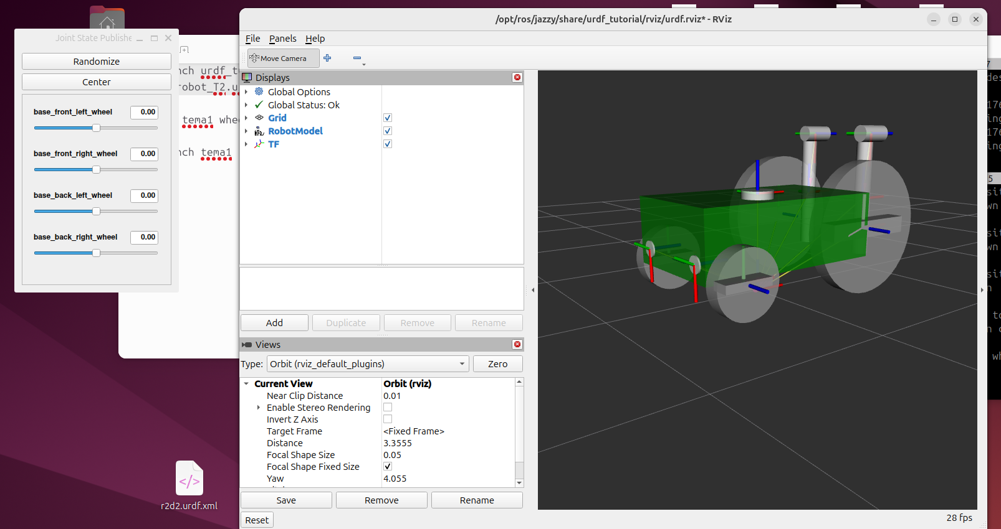

Salvare:
Save as-> .rviz -> robot.rviz (cum am salvat eu, cel putin; si se pastreaza pentru mai incolo, preferabil pe descktop)

Cap 2, Packetul

Revenim la pachetul creat anterior, si creem un node nou de folosit:
$ cd ../.. (pentru a intra in ros2_ws, src, tema1, tema1; unde tinem nodurile)
$ touch wheel_movement_node.py (creem un node nou)
$ chmod –x wheel_movement_node.py (o facem executabila)
$ code wheel_movement_node.py (sa editam cu urmatorul code)
import rclpy
from rclpy.node import Node
from sensor_msgs.msg import JointState
import math
import threading
import time

class WheelMovementNode(Node):
def __init__(self):
super().__init__('wheel_movement_node')

self.joint_pub = self.create_publisher(JointState, '/joint_states', 10)

# Variables for animation
self.current_angle = 0.0
self.target_angle = 0.0
self.animation_speed = 0.1 # Radians per tick

# Run the publisher loop at 30Hz for smooth animation
self.timer = self.create_timer(0.033, self.update_and_publish)

self.get_logger().info("Wheel node ready.")
self.get_logger().info("[Exemple: (Correct:5); (Incorrect:5m)]")
self.get_logger().info("Type a distance and hit Enter:")

# Input thread
self.input_thread = threading.Thread(target=self.input_loop)
self.input_thread.daemon = True #tl;dr: the daemon is used to promptly retrive node and topic information. <-from github:
#https://github.com/clearpathrobotics/roscon2024-workshop-demystifying-ros2-networking/blob/main/exercises/2_daemon.md
self.input_thread.start()

def input_loop(self):
while rclpy.ok():
try:
user_input = input("Target Distance: ")
distance = float(user_input)

# Calculate the target angle
wheel_circumference = 1.0 #perimetru rotilor
total_rotation = (distance / wheel_circumference) * 2 * math.pi

self.target_angle = total_rotation # *180/pi pt deg
self.get_logger().info(f"Moving to angle: {self.target_angle:.2f} rad")

except ValueError:
print("Incorrect.")

def update_and_publish(self):
# -- Animation Logic --
# Slowly move current_angle towards target_angle
if abs(self.current_angle - self.target_angle) > 0.01: #abs = Returns the absolute value of a number. Ex: |-3| = 3
if self.current_angle < self.target_angle: # Ex: |0 (original) - n|=m; m<n (unghi dorit)=> misca inainte
self.current_angle += self.animation_speed # m<n (unghi dorit)=> misca inapoi
else:
self.current_angle -= self.animation_speed
else:
# Snap to exact value if very close
self.current_angle = self.target_angle

# -- Publish --
# Create a new JointState message object
msg = JointState()

# Add a timestamp. This is CRITICAL for RViz/TF.
# It tells the system "this is where the joints are AT THIS MOMENT."
msg.header.stamp = self.get_clock().now().to_msg()

# List the names of the joints exactly as they appear in your URDF.
msg.name = [
'base_front_left_wheel',
'base_front_right_wheel',
'base_back_left_wheel',
'base_back_right_wheel'
]

# Assign the current rotation (in radians) to each joint.
msg.position = [
self.current_angle,
self.current_angle,
self.current_angle,
self.current_angle
]

# Send the message to the /joint_states topic.
# Robot_state_publisher hears this and updates the 3D model.
self.joint_pub.publish(msg)

def main(args=None):
rclpy.init(args=args)
node = WheelMovementNode()

try:
rclpy.spin(node)
except KeyboardInterrupt:
pass
finally:
node.destroy_node()
rclpy.shutdown()

if __name__ == '__main__':
main()

Editam apoi setup.py creat anterior:
data_files=[
('share/ament_index/resource_index/packages',
['resource/' + package_name]),
('share/' + package_name, ['package.xml']),
('share/' + package_name + '/launch', ['robot.launch.py']),
('share/' + package_name + '/rviz', ['robot.rviz']),
],
-- and --
entry_points={
'console_scripts': ['intsqare = tema1.intsqare:main',
'client = tema1.client:main',
'wheel_movement = tema1.wheel_movement_node:main',
],
Apoi folosim $touch si $chmod din nous a facem un robot.launch.py in tema1 (primul nu cel cu nodurile) si intrducem codul urmator:
import os
from launch import LaunchDescription
from launch_ros.actions import Node

def generate_launch_description():
urdf_file = os.path.join(
os.getenv('HOME'), 'Desktop', 'robot_T2.urdf'
)

with open(urdf_file, 'r') as f:
robot_description = f.read()

rviz_config = os.path.join(
os.getenv('HOME'), 'ros2_ws', 'src', 'tema1', 'robot.rviz'
)

return LaunchDescription([
# 1. Publishes the robot structure (URDF) to TF
Node(
package='robot_state_publisher',
executable='robot_state_publisher',
output='screen',
parameters=[{'robot_description': robot_description}],
),

# 2. Opens RViz
Node(
package='rviz2',
executable='rviz2',
arguments=['-d', rviz_config],
output='screen',
),
])
Ne trebuie ambele (urdf si .rviz), urdf e schita, practice modelul in sine si .rviz exte cel care pune/animeaza [ps: sa se modifice path-urile daca sunt in alte parti puse decat la mine]
Acum punem .rviz in pachet sau unde vrem (atata timp cat avem conectat path-ul correct in launch…)
Si dam $ colcon build in ros2_ws, apoi $ source /opt/user/distributie/setup.bash si folosim urmatoarele comenzi in terminale diferite (dup ace dam source in fiecare):
$ ros2 run tema1 wheel_movement

$ ros2 launch tema1 robot.launch.py

